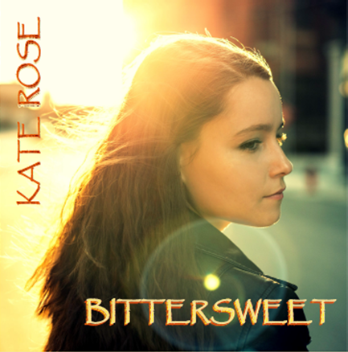

Career Highlights…

2013 GRAMMY Music Revolution Project

Official Showcase Artist- 2015 FAI conference

The Aftershock- Merriam, KS

The AllStar Rock Bar- Kansas City, MO

Holy Cow Market and Music- Kansas City, MO

El Torreon- Kansas City, MO

Union Station’s Centennial Celebration 2015

Make Music Liberty 2016/7 - Liberty, MO

PorchFest 2016/7 - Kansas City, MO

Middle of The Map Fest 2017, RecordBar- KCMO

Featured Artist - Tech N9ne album “Special Effects”

Featured Artist - Tech N9ne “The Storm”

Featured Artist - Prozaks’ album “Black Ink”

Featured Artist - C The Gray’s album “Class of”

Kate on the web…

Website: [http://www.purerosemusic.com](http://purerosemusic.com)

Soundcloud: <https://www.soundcloud.com/kate-rose-18>

ReverbNation: <http://www.reverbnation.com/katerose4>

Facebook: <https://www.facebook.com/PureRoseMusic>

Twitter: <https://www.twitter.com/purerosemusic>

Instagram: <https://instagram.com/pure.rxse/>

***“****… her songs reveal real talent.” -***Listen Local**

Photo credit: Aaron Cedeño/Lumos Images (KS)

Kate Rose

Through all of her experiences- Kate has evolved into quite the skilled musician over the last 6 yrs. and at 19, her music still reflects a glimmer of childlike innocence mixed with the savvy of her adult self.

Think Stevie Nicks, Janis Joplin, mixed with Joni Mitchell, a hint of Adele, Alessia Cara and samplings of artists like Bea Miller, Colbie Caillat, Florence Welch, Christina Perri, and Skyler Grey to name a few.

Basically, if you were to place a dot on a graph for every female vocalist over the last 50 years- Kate would fall somewhere in the middle.

*“Both Tech and I agree that Kate is definitely something special."*  - **Michael "Seven" Summers (Strange Music)**

For bookings or inquiries, please e-mail

[purerosemusicllc@gmail.com](mailto:purerosemusicllc@gmail.com?subject=Booking/inquiry)